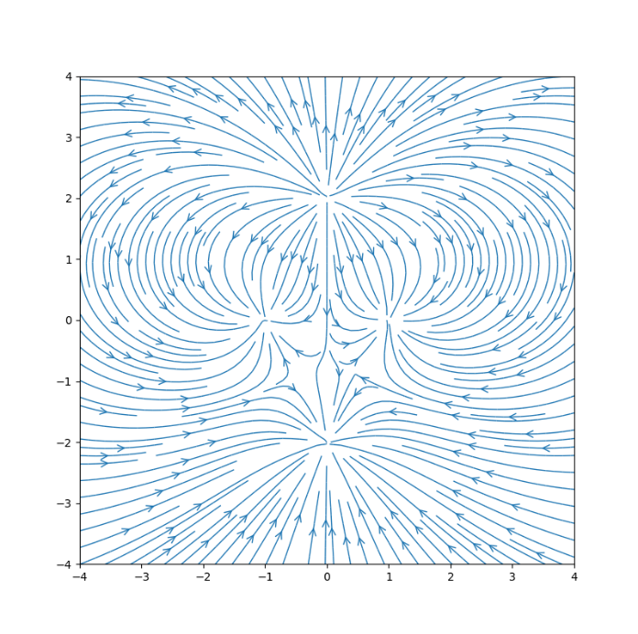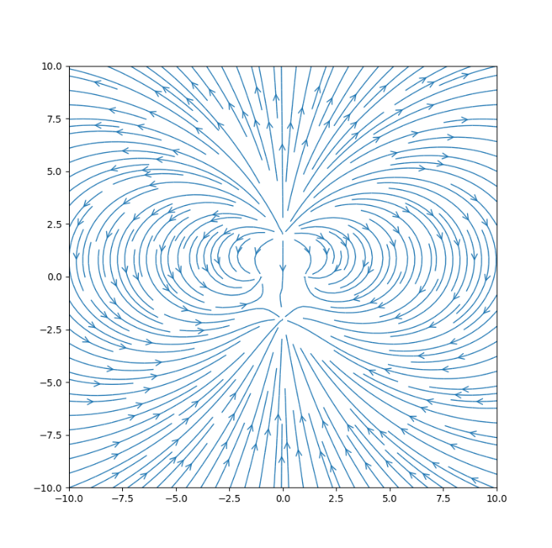

E field from -4 to 4 E field from -10 to 10

My code is as follows:

# -*- coding: utf-8 -*-

"""

Created on Tue Oct 15 09:03:29 2019

@author: Nick

"""

import numpy as np

import matplotlib.pyplot as plt

# Grid of x, y points

L=10

nx, ny = 100, 100

x = np.linspace(-L, L, nx)

y = np.linspace(-L, L, ny)

X, Y = np.meshgrid(x,y)

# Constants

eps0 = 8.854e-12

k = 1/(4*np.pi*eps0)

# Variables

a = 1

b = 2

q = 1

def Ex(qq,aa,bb):

return k*qq*(X-aa)/((X-aa)**2+(Y-bb)**2)**(3/2)

def Ey(qq,aa,bb):

return k*qq*(Y-bb)/((X-aa)**2+(Y-bb)**2)**(3/2)

Ex = Ex(-q,a,0) + Ex(-q,-a,0) + Ex(3*q,0,b) + Ex(-q,0,-b)

Ey = Ey(-q,a,0) + Ey(-q,-a,0) + Ey(3*q,0,b) + Ey(-q,0,-b)

# demo of streamplot for a vector field

fig = plt.figure(figsize = (8,8))

plt.streamplot(x, y, Ex, Ey, linewidth=1, density=2, arrowstyle='->', arrowsize=1.5);